RETURN TO PLAY

GUIDELINES AND PLAN

(as of February 1, 2021)

INTRODUCTION

Jericho Little League Baseball Association (“Jericho”) operates a baseball league for children between the ages of 3 to 12 on the westside of Vancouver. Jericho has been chartered by Little League Baseball since 1999 and together with Dunbar Little League, Kerrisdale Little League and Little Mountain Baseball constitute District 1 of Little League BC.

Jericho’s territory covers all of Kitsilano, Point Grey, UBC, and other parts of Vancouver. A map of our territory is below:

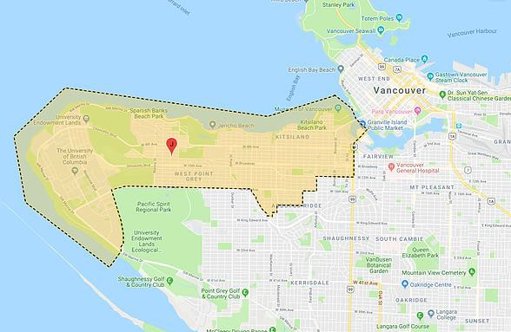

Our home field is Carnarvon Park on West 16th Avenue where we have two playing fields, a club house, concession stand, a bullpen training facility, and a batting cage. Jericho also uses Trimble Park on West 8th Avenue, where we maintain three playing fields; Jericho Park on North West Marine Drive, where we have one playing field; and Noble Park, a playing field on Wesbrook Mall.

For the 2020 season, prior to our season being suspended, Jericho had close to 500 registered players in 7 divisions and more than 100 players in winter training programs for varying age groups. Our modified summer season, which was conducted under Phase 2 conditions defined by viaSport and Baseball BC, attracted more than 180 players, with all but the youngest division represented.

The typical baseball season starts with team formation in March and commencement of practice in early April. Games start after Easter, with playoffs beginning in June and concluding in mid-month on Championship Day. Players chosen for Select and All-Star teams are able to continue playing through mid-July or longer.

Depending on the age group, our principal program consists of one or two practices each week for skill development, with one or two weekly games. We believe, however, that our program is more than just bats and balls. We try to instill in our players the Little League mission of developing character, courage, and loyalty and teaching the rewards of team work, a respect for authority, and the self-discipline that will enable them to become the leaders of tomorrow.

JERICHO’S RETURN TO PLAY PLAN

We have carefully reviewed BC Ministerial Order 183/2020 (June 10, 2020) and the viaSport and Baseball BC guidelines, as well as our experience conducting a modified summer season in 2020. Based on those considerations, we have developed the present plan to enable Little League activities this spring.

Our Plan is designed:

- to establish safety measures in accordance with viaSport and Baseball BC Return-to-Play guidelines, and to facilitate transitions between RTP phases announced by the province and Baseball BC;

- to set forth additional measures as needed to keep players, volunteers, and (if allowed) spectators safe while engaging in Jericho activities;

- to educate the Jericho community about the RTP safety measures, equip coaches with the supplies they need to implement them, and monitor each team’s compliance; and

- to document implementation of the plan.

and is consistent with and follows the 5 principles as directed by the Provincial Health Officer, government and ViaSports as follows:

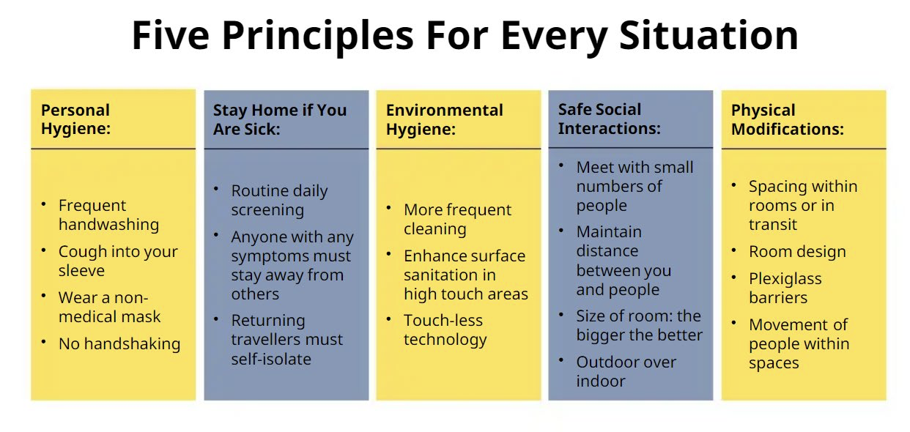
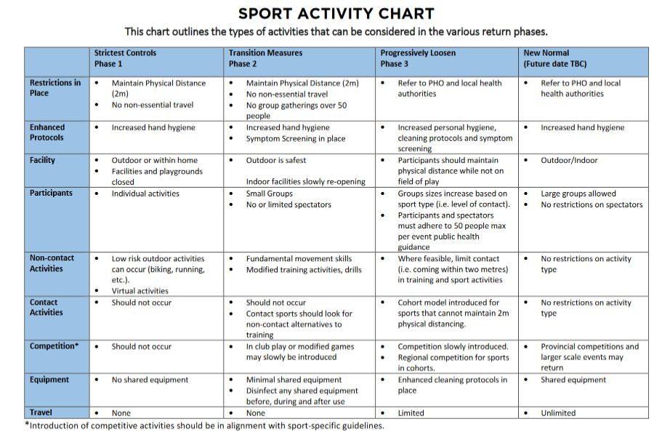

BC Baseball Return-to-Play Measures

Baseball BC has established a system of guidelines consistent with the four phases laid out in the viaSport guidelines - https://baseball.bc.ca/return-to-play. Jericho’s modified summer season took place entirely under the rules associated with Phase 2, with some restrictions loosened as conditions in the province improved and viaSport and Baseball BC announced a gradual transition to the next Phase.

Jericho will closely monitor viaSport and Baseball BC for any shifts in phase or further adjustments to the rules and will implement any changes expeditiously, to ensure continued adherence. Based on prevailing conditions, our events may be restricted to small-group activities or may be expanded to allow intraleague games, to give but two examples. We will follow the applicable viaSport Phase guidelines and Baseball BC that are in place during the season, which will include the following

- Verbal symptom screening must be performed at every session to ensure all participants are symptom free.
- All government expectations and requirements to be met, as set forth in viaSport, Return to Sport Guidelines for BC (last rev. Aug. 2020)).
- 3m physical distance required between participants.
- Every event to include reminders to participants regarding 3m physical distancing and include no spitting, no face touching, no contact between the athletes.
- Attendance must be taken and kept at every event for all people in attendance including parents (drivers). These records must be kept for 30 days before being destroyed.
- No team huddles before, during or after the practice for coaching or teaching purposes unless 3m physical distancing requirements are adhered to.
- All drills to be created and implemented ensuring 3m physical distancing is adhered to.
- Activities should be low risk of transmitting the virus
- No dugout use permitted. Athletes must be set up outside of the dugout with 3m physical distancing requirements adhered to.
- No shared use of personal equipment.
- Baseballs should be sanitized prior to every event and every effort given to limit the number of athletes using one ball in a practice environment.
- Any team issue bats should be sanitized prior to every event and between every use by different athletes. No other team equipment should be shared.
- No changing or dressing rooms permitted.
- All field prep equipment to be disinfected and cleaned after every use.
- Indoor practices are permitted so long as the facility is operating in accordance with Provincial, Regional, and Municipal COVID-19 regulations.
- All Baseball BC Personal Health and Hygiene Recommended Guidelines to be reviewed and enforced as outlined below:
- Anyone displaying ANY illness symptoms MUST NOT attend.
- Disinfectant wipe down of all surfaces athletes can be exposed before every event.
- Reminder to all participants daily to avoid touching of eyes, nose, or mouth.
- No sharing of water bottles.
- No sharing of food of any kind.
- No spitting; and no chewing gum or sunflower seeds.
- No sharing of any personal equipment or items.
- Ride sharing to be discouraged whenever possible.
- All participants encouraged to disinfect their equipment after each event.
- All participants encouraged to wash all clothing and selves after each event.

Additional Jericho Measures for Safety, Education, and Monitoring

Pre-season administration

• RTP Committee.— In early February, Jericho will reconvene a Return-to-Play Committee, consisting of our President, Vice-President, Safety Officer, Administrator, and interested Board members and volunteers, for purposes of reviewing, approving, and implementing this plan. As in 2020, the Committee will be led by Jericho’s Safety Officer.

• Registration.— As in past years, the league will use an online process for player registration and payment, avoiding the need for personal contact.

• Waivers.— All players and their families, and coaches and other volunteers, will be required to sign risk waivers and the participant agreement (as described in the viaSport guidelines) as appropriate. As part of our process of obtaining waivers and releases, Jericho will obtain consent from players and their families to disclose their personal information for purposes of facilitating contact tracing in the event of an outbreak.

• Availability of plan.— All players and their families, and coaches and other volunteers, will be provided with a copy of this safety plan. Jericho will post the updated safety plan, waiver, participant agreement, and other documents to the league’s website so they are easily accessible.

Education and communications

• Apps.— Jericho will use TeamSnap, an online team management app, as well as email to facilitate necessary communications with volunteers.

• Signage.— The league will post signs at each field assigned for use during the 2021 season: a sign reminding participants of basic safety rules, such as maintaining required separation distances; a signs at each dugout forbidding entry.

• Meetings and video.— Jericho will hold at least one virtual pre-season safety meeting for coaches, led by the Safety Officer with other members of the RTP Committee. Additionally, as in 2020, Jericho intends to post a video for coaches and players, before the season starts, to walk them through the rules of safe play.

• “Cheat sheets.”— As in 2020, the RTP equipment bag issued to each team will include a laminated, pocket-sized “cheat sheet” for each coach, summarizing her responsibilities at each event for RTP safety.

• Team visits.— Again as in 2020, the RTP Committee will visit each team at least once at the beginning of the season to coach volunteers on the safety guidelines.

General measures

• Equipment.— Before the season begins, Jericho will equip each team with RTP safety supplies, including hand sanitizer, disinfectant wipes, and masks for first aid, and will replenish each team’s supplies as needed.

• Outdoor play.— All games and practices will be held outdoors. Indoor training programs are suspended pending further directives from health authorities.

• Arrival and departure.— Practice and game times will be modified to ensure at least fifteen minutes between events. Teams will be required to vacate the field immediately after their games and practices if followed by another event, and will be asked not to arrive early, and to wait in their cars or elsewhere in the park for the preceding team to relinquish the field.

• Hand sanitizing.— As part of our detailed arrival procedure, all players and on-field coaches and volunteers will be required to use hand sanitizer prior to entering the field of play.

• Masks.— Due to the outdoor nature of the sport, Jericho will not require that participants wear masks unless directed by the province or another health authority or by viaSport or Baseball BC. However, any participant wishing to play with a mask will be permitted to do so.

• First aid.— In the event that first aid is required to be administered during an activity, all persons attending to the injured individual must first put on a mask and gloves. Each team will be equipped with masks and gloves for this purpose. Jericho’s general safety plan contains additional information about first-aid protocols and treatment of common injuries.

• Spectators.— If Baseball BC permits spectators, Jericho will assign a safety monitor to each team or game, to ensure that numbers do not exceed provincial or other limits. Jericho will communicate with families to encourage equitable and mindful spectatorship: limiting each player to one guest, practicing social distancing, etc.

• Contact tracing.— As in 2020, Jericho will supply each team with specialized attendance sheets to facilitate tracking, and coaches will be required to send the Safety Officer photos of their attendance sheets after each event. The Safety Officer will keep updated records throughout the season and for at least 30 days after the season ends. All players and their families will be required to consent to disclosure of their information for contact-tracing purposes in the event of an outbreak.

• Documentation.— The Safety Officer will document league compliance with the viaSport and BC guidelines. This will include keeping attendance sheets and recording compliance of teams with attendance screening; photographing signage at each field and contents of safety supply bins; logging team visits; and recording issues as they arise.

Facilities

• Concession.— We will not operate the concession. The kitchen area is not big enough to ensure social distancing and not having a concession will encourage and facilitate people leaving Carnarvon after practices and events.

• Club House.— The Club House at Carnarvon Park will remain in use as a storage facility, with restricted access to coaches for retrieving needed playing and safety equipment. The league will continue to hold Board and coach meetings via online platforms rather than use the Club House. If games are permitted, the Club House will be closed to umpires as a change room and lounge; umpires will be expected to arrive dressed and to abide by the arrival and departure timelines described above.

• Dugouts.— In accordance with Baseball BC guidelines, dugouts will not be used until further notice, and a sign prohibiting entry will be posted at each dugout. Players will set up their equipment outside of the dugout with physical distancing requirements adhered to.

Infection/Outbreak Plan

Jericho will respond to signs of illness in accordance with our Illness Policy (Appendix A). If an infection or outbreak occurs, all play and practices will be suspended in accordance with our Outbreak Policy (Appendix B). Information regarding the infection will be provided to health authorities along with contact information for anyone who might have come in contact with the source of the infection.

Volunteers

None of this will work without an army of volunteers. All registrant families will be required to play a role to ensure that our plan works and that everyone stays safe. In the past, each Jericho team has typically recruited two or three coaches and a team manager. We will now also request a safety manager for each team.

CONCLUSION

Thank you for reviewing and assessing Jericho Little League Baseball’s Return to Play Plan. We
trust you have found it to be consistent with Provincial Health Authority and ViaSport
guidelines and is intended for a return to little league baseball play in a manner and format that reduces the risk of Covid-19 spread or outbreak.

If you have any questions regarding our plan, please contact any of the following:

Doug (DA) Anderson, President
Dean Murray, Vice President
Michael Jasny, Safety Officer
APPENDIX A - ILLNESS POLICY

In this policy, “Team member” includes a volunteer, participant or parent/spectator.

1. Inform an individual in a position of authority (coach, team manager, program coordinator) immediately if, you feel any symptoms of COVID-19 such as fever, chills, cough, shortness of breath, sore throat and painful swallowing, stuffy or runny nose, loss of sense of smell, headache, muscle aches, fatigue and loss of appetite.

2. Assessment

a. Managers/coaches will ask Team Members screening questions before their practice/activity.

b. Managers/coaches will visually monitor Team Members to assess any early warning signs as to the status of their health and to touch base on how they are regarding their personal safety throughout the practice/activity.

c. If Team members are unsure, please have them use the self-assessment tool https://bc.thrive.health/covid19/en or through the COVID-19 BC Support App self- assessment tool.

3. Symptoms

If a Team Member is feeling sick with COVID-19 symptoms

a. They should remain at home and contact Health Link BC at 8-1-1.

b. If they feel sick and /or are showing symptoms, they should be sent home immediately and have them contact 8-1-1 or a doctor for further guidance.

c. No Team Member may participate in a practice/activity if they are symptomatic.

4. Positive Test

If a Team Member tests positive for COVID-19:

a. The Team Member will not be permitted to return to any activity until they are free of the COVID-19 virus.

b. Any Team Members who were in close proximity or at same activity with the infected Team Member will also be removed from all activities for at least 14 days to ensure the infection does not spread further.

c. Close off, clean and disinfect their practice area immediately and any surfaces that could have potentially be infected/touched.

5. Waiting for Test Results

If a Team Member has been tested and is waiting for the results of a COVID-19 Test:

- As with the confirmed case, the Team Member must be removed from activities.

b. The Public Health Agency of Canada advises that any person who has even mild symptoms to stay home and call the public health authority of B.C.

c. Other Team Members who may have been exposed will be informed and removed from the activities for at least 14 days or until the diagnosis of COVID-19 is ruled out by health authorities.

d. The practice/ activity space will be closed off, cleaned, and disinfected immediately and any other surfaces that could have potentially been infected/touched.

6. Contact

a. If a Team Member has come in to contact with someone who is confirmed to have COVID-19 a. Team Members must advise their coach or program coordinator if they reasonably believe they have been exposed to COVID-19.

b. Once the contact is confirmed, the Team Member will be removed from the activity for at least 14 days or as otherwise directed by public health authorities. Team Members who may have come into close contact with the Team Member will also be removed from the workplace for at least 14 days.

c. The activity area will be closed off, cleaned, and disinfected immediately and any other surfaces that could have potentially been infected/touched.

7. Quarantine or Self-Isolate if:

a. Any Team Member who has travelled outside of Canada or the province within the last 14 days is not permitted to enter any part of the facility and must quarantine and self-isolate.

b. Any Team Member with any symptoms of COVID-19 is not permitted to enter any part of the facility and must quarantine and self-isolate.

c. Any Team Member from a household with someone showing symptoms of COVID-19 is not permitted to enter any part of the facility and must quarantine and self-isolate.

d. Any Team Member who is in quarantine or self-isolating as a result of contact with an infected person or in families who are self-isolating, is not permitted to enter any part of the facility.

APPENDIX B - OUTBREAK PLAN

Early detection of symptoms will facilitate the immediate implementation of effective control measures. In addition, the early detection and immediate implementation of enhanced cleaning measures are two of the most important factors in limiting the size and length of an outbreak. An “outbreak” is two or more cases; a “case” is a single case of COVID-19.

1. The Jericho Board, working with the Return-to-Play Committee, will take leadership if a case or outbreak is reported. They have the authority to modify, restrict, postpone, or cancel activities.

2. If staff (including volunteers) or a participant reports they are suspected or confirmed to have COVID-19 and have been at a Jericho activity, we will implement enhanced cleaning measures to reduce risk of transmission. In addition, we will implement your illness policy and advise individuals to:

• self-isolate;

• monitor their symptoms daily, report respiratory illness and not to return to activity for at least 10 days following the onset of fever, chills, cough, shortness of breath, sore throat and painful swallowing, stuffy or runny nose, loss of sense of smell, headache, muscle aches, fatigue and loss of appetite; and

• use the COVID-19 self-assessment tool at BC COVID-19 Self-Assessment Tool to help determine if further assessment or testing for COVID-19 is needed. Individuals can contact 8-1-1 if further health advice is required and 9-1-1 if it is an emergency. Individuals can learn more about how to manage their illness here: http://www.bccdc.ca/healthinfo/diseases-conditions/covid-19/about-covid-19/if-youare- sick.

3. In the event of a suspected case or outbreak of influenza-like-illness, we will immediately report and discuss the suspected outbreak with the Medical Health Officer (or delegate) at our local health authority, and implement our Illness Policy.

4. If contacted by a Medical Health Officer in the course of contact tracing, we will cooperate with local health authorities.

